James Franklin Bright
December 30, 1883 – December 12, 1952

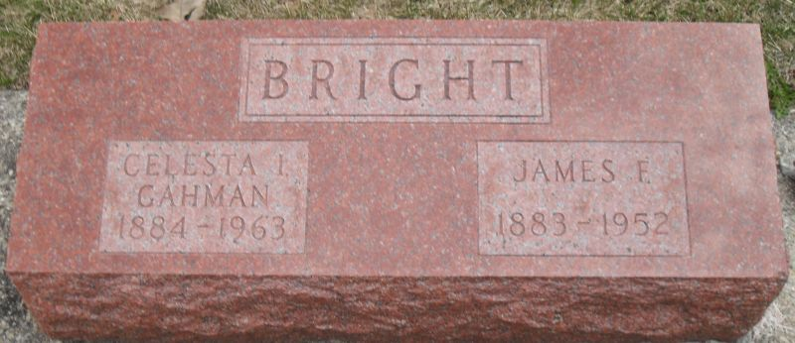
Photo by Stephen & Andrea Brangan
James F. Bright Dies Last Night
Funeral Services Tuesday Afternoon
James Franklin Bright, 68, retired railroad employee, died at 11 o'clock Friday night at his home two miles south of Tocsin following a heart attack. He was born Dec. 20, 1883, a son of Joshua and Sara Baum-Bright, and was married to Celesta Gahman Nov. 17, 1906.
Mr. Bright was a member of the United Brethren church at Tocsin.
Surviving in addition to his wife are three sons, Martin L. of Sharron, Pa., Wallace H. and Gerald Bright, both of Bluffton; three daughters, Mrs. Earl Woodworth of Phoenix, Ariz., Mrs. Wade Bowman of Zanesville and Mrs. Harold Blue of Fort Wayne; five grandchildren, and a sister, Mrs. Bessie Mueller of Fort Wayne.
Funeral services will be conducted at 2 p.m. Tuesday at the Pleasant Dale Church of the Brethren in Kirkland Township, the Rev. J. F. Bright officiating. Burial will be in the church cemetery. The body is at the Jahn Funeral Home in Bluffton, and will be removed to the residence, where friends may call after 2 p.m. Monday.
Decatur Daily Democrat, Adams County, IN; December 13, 1952
*****

James Bright, 68, Succumbs at Home
James Franklin Bright, 68, of Craigville Route 1 died at 11 o'clock Friday evening at his home. Death was attributed to a heart attack and had been ill a short time.
The decedent was born Dec. 30, 1883 in Adams County to Joshua and Sarah Baum Bright. His marriage to Celesta Gahman, who survives, took place in Bluffton Nov. 17, 1906.
Mr. Bright was a retired railroad man and a member of the United Brethren Church of Tocsin. He had been a resident of Wells County for 40 years.
Surviving in addition to the wife are three daughters, Mrs. Earl Woodworth of Phoenix, Ariz.; Mrs. Wade Bowman of Zanesville; and Mrs. Harold Blue of Fort Wayne; three sons, Martin L. of Sharon, Pa.; Wallace H. and Gerald F. of Bluffton Route 4; a sister, Mrs. Bessie Muller of Fort Wayne and five grandchildren.
The body was taken to the Jahn Funeral Home, where friends may call after 1 o'clock Sunday afternoon. The body will be taken to the home in Lancaster Township Monday, where friends may call after 1 o'clock Monday afternoon.
Funeral services will be held at 2 o'clock Tuesday at the Pleasant Dale Church, Kirkland Township, Adams County, with Rev. J. F. Bright officiating. Burial will be in the church cemetery.
Bluffton News-Banner, Wells County, IN; December 13, 1952

