Glen J. Baumgartner
February 20, 1911 – November 7, 1981

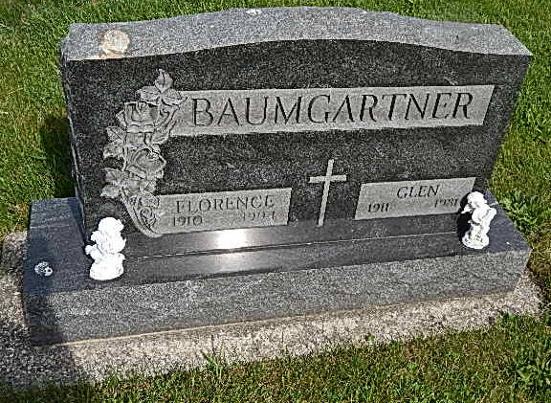
Photo by Alicia Kneuss
Heart Attack is Fatal for Glen J. Baumgartner, 70
A resident of 1003 Lewis Dr. in Decatur, Glen J. Baumgartner, 70, was dead upon arrival at 12:35 p.m. Saturday at Decatur Hospital. Mr. Baumgartner became suddenly ill, with death attributed to a heart attack. Operator of the Peterson Grain Co. for 16 years, Mr. Baumgartner was retired after being employed four years by the Schafer Co. in Decatur.
Born Feb. 20, 1911 in Adams County, he was a son of Joe and Viola Beitler Baumgartner. His marriage to Florence Werling, who survives, took place May 22, 1931.
In addition to the wife, he is survived by a daughter, Mrs. Leonard (Bonnie) Funk of Decatur; two brothers, Roy W. Baumgartner of Decatur and Don H. Baumgartner of Hatfield, Pa.; two sisters, Mrs. John (Anna) Rodich of Berne Route 1 and Mrs. Alice McGough of Monroe Route 1, three grandchildren and four great-grandchildren.
Calling from 2 to 5 and 7 to 9 today will be at the Winteregg-Linn and Haggard Funeral Home in Decatur. Services there at 10 a.m. Tuesday will be in charge of Rev. John Niederhaus and burial will be in the Pleasant Dale Cemetery.
Bluffton News-Banner, Wells County, IN; November 9, 1981

