PFC Carl David Baumgartner
December 4, 1919 – August 18, 1943
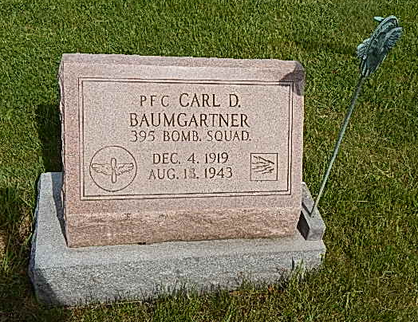
Photo by Alicia Kneuss

Thursday, April 19, 1943

Adams County Youth Killed in Air Crash
Carl D. Baumgartner is Killed in Kansas

Carl David Baumgartner, 23, son of Mr. and Mrs. Joe Baumgartner, of Kirkland Township, was killed in the crash of a United States Army bomber near Pratt, Kansas, Wednesday, according to a telegram received by the parents early this morning.
Baumgartner, a private, first class, was a radio operator on the bomber.
He enlisted in the air force in April, 1942, and was inducted into the Army at Fort Benjamin Harrison, Indianapolis, May 15 of last year. He had been in service in the Panama Canal, Mexico and California and was only recently transferred to the Army air base at Pratt. He was home on furlough about four weeks ago.
Although no details were contained in the telegram received by the parents, it is believed that Baumgartner was not killed instantly. The word, from Col. J. W. Hammond, commander of the air base at Pratt, stated that the crash occurred at 10:00 am Wednesday, but the telegram announcing Baumgartner’s death was timed at 10:05 pm last night.
The air tragedy victim was born in this county, December 4, 1919, the son of Joe and Viola Baumgartner. He graduated from Kirkland High School, where he starred on the basketball team, having captained the squad in his senior year.
Surviving besides the parents are five brothers (cut off) Baumgartner, son-in-law of Mr. and Mrs. Floyd Acker of this city, stationed with the U.S. Army at Camp Beal, Calif.; Roy of Decatur; Linn, of Preble, Russell of Peterson and Don Baumgartner, at home; and three sisters: Mrs. Esther Yager of near Fort Wayne; Mrs. Alice Smith of Adams County and Mrs. Anna McKean of near Monroe. Mrs. Smith’s husband, Otto Smith, Jr., was killed in an airplane crash near Berne a few years ago.
The body will be returned to the Yager Funeral Home at Berne, although no word had been received this afternoon as to time of arrival.

Adams Co Historical Museum
1943A Scrapbook, image 19
Transcribed by Jim Cox

LOCAL SOLDIER DIES IN KANSAS BOMBER CRASH
Pfc. Carl D. Baumgartner, 23, one of six killed Wednesday night.

Pfc. Carl David Baumgartner, 23, son of Mr. and Mrs. Joseph Baumgartner of Kirkland Township, but who until a few months ago resided on the Gideon Riesen farm of Jefferson Township, east of town. He was killed in an airplane accident at 10:35 o'clock Wednesday morning. According to word received from his parents by telegram that night. This message was sent by Col. J.W. Hammond, commanding officer at the army base at Pratt, Kansas. No particulars were received with the message of the tragedy, but news wires later yesterday carried an account of the accident, stating that six members of the bombing crew were killed when their ship crashed while on a routine flight near their base of Pratt. Pfc. Baumgartner was a radio operator on the bomber, and was listed among the casualties.
The body is being shipped here to the Yager mortuary, and will arrive here via Pennsylvania railroad Saturday afternoon, according to the information received here today. It will be taken to the Baumgartner residence which is located a mile north and three miles west of Monroe. The body will be escorted here by Pfc. Richard M. Hoe from the Pratt army base.
Pfc Baumgartner enlisted in the U.S. Army Air Corps in April of 1942, while his family was residing east of town. He entered the service May 15, and was introduced at Fort Benjamin Harrison at Indianapolis. From there he was sent to Keesler Field Mississippi, and then to Scott Field Illinois. His training was to prepare himself at radio operation in a bomber. After a few weeks at Scott Field, was sent to New Jersey, and then to Florida. After some training in Florida he was sent to the Panama Canal for more training. Later was sent to California and now in Kansas.
The ill-fated young man was born in French Township on December 4, 1919, the son of Joseph and Viola Butler-Baumgartner, and spent most of his childhood in this part of the country. His is the second fatality in the family in a little over a year caused by airplane accident. His brother-in-law, Otto Smith Jr. was instantly killed in a plane crash while piloting a plane out of Fort Wayne, falling on the Menos Wulliman farm north-west of town on Sunday, March 30, 1941, when his plane stalled and nose-dived from low altitude.
Surviving are the parents and the following brothers and sisters; Mrs. Charles Yager of Fort Wayne, Russell of Peterson, Glen Otto Smith Jr, residing on Decatur rural route 4, Pvt. Dale Baumgartner of California and Don at home. A brother John preceded him on December 1941. Pfc. Baumgartner was a member of the Pleasant Dale Church of the Brethren of which Rev. Russell Weller is pastor. Funeral services will be held at church on Monday afternoon at 2 o'clock. There will be no military services. Services had earlier been planned for Sunday afternoon, but word was received from the ill-fated youth's brother. Pvt. Dale, stationed in California, that he is coming for the funeral.
Since the family moved the Kirkland township in recent months, the death message was sent to the parents with the Baumgartner address. A telegraph messenger from Decatur who carried the message here experienced difficulty in locating the family. I. L. Yager, local undertaker and a cousin of Mrs. Baumgartner was finally contacted and he accompanied the messenger to the home and delivered the sad new to the family.

Berne Witness, Adams County, IN; August 20, 1943
Courtesy of the Berne Library Heritage Room
Transcribed by Gabriella Brouillette Smith

