William N. Barger
1851 – June 25, 1923

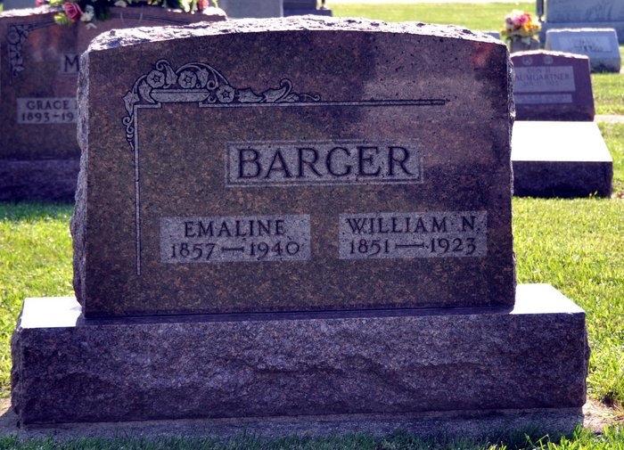
Photo by Deb Curry

WILL BARGER DIES IN ADAMS COUNTY
FARMER LIVING EAST OF TOCSIN IS VICTIM OF BRIGHT'S DISEASE
William Barger, 72 years old, died at 3:35 o'clock this morning at his home two miles east of the Little Vine church, after an extended illness with Bright's disease.
Mr. Barger had lived near the Adams-Wells County line since a child, having come with his parents from Ohio.
Surviving is the widow and four daughters, Mrs. Thomas Griffith, Mrs. Will Jackson, Mrs. Sovine, all of Adams County, and Kate at home. Brothers and sisters are: Ed Barger, of Wells County, Sam, Jake and John, of Adams County; Mrs. Rose Wolf, of Tocsin, and Mrs. Susie Arnold, Mrs. Sophia Mankey and Mrs. Mary Bryant, all of Adams County.
The funeral will be held at 2 o'clock Wednesday afternoon at the Pleasant Dale Church.
Bluffton Evening Banner, Wells County, IN; June 25, 1923

