Homer W. Arnold
March 11, 1898 – January 7, 1990

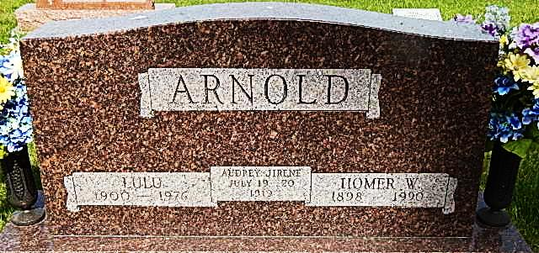

Homer W. Arnold, 91, route 2, Decatur, died at 8:30 p.m. Sunday in Adams County Memorial Hospital.
He was born in Adams County on March 11, 1898 to William and Anna Hower Arnold. He married Lulu Byerly on March 15, 1919; she died May 31, 1976. He married Lela Schlickman Arnold on August 19, 1980; she survives.
He was a lifelong Adams County resident, a prominent retired Kirkland Township farmer, and a former partner and manager of Decatur Ready Mix from 1952-72. He was active in many agricultural programs and was a life member of the Adams County Farm Bureau.
He was a member of St. Mark's United Methodist Church, of which he was a former trustee, and was a Sunday school teacher. Mr. Arnold was instrumental in organization of the Adams Central school district, serving on its first school board.
Other survivors include five sons: Stanley D. Arnold, route 6, Decatur; Eugene B. Arnold, route 4, Decatur; Don H. Arnold, Milford, Ind.; Bill L. Arnold, route 5, Wabash; and Homer Junior Arnold of Berne; three stepsons, Darrel Arnold, route 2, Decatur; Jim E. Arnold, route 4, Decatur and Harold Arnold, Monroe; one brother, Vernon Arnold of Benson, Ariz.; two sisters, Mary Arnold and Mrs. True (Elsie) Andrews, both of Decatur; 19 grandchildren; 10 step-grandchildren; 29 great-grandchildren; 17 step-great-grandchildren; one step great-great-granddaughter. One daughter, one sister, one brother and one great-grandson are deceased.
Funeral services are at 10:30 a.m. Wednesday at St. Mark's United Methodist Church, Revs. James S. Hook and Norman Replogle officiating. Burial will be in Pleasant Dale Cemetery. Pallbearers will be Duane Arnold, Phil Arnold, Alan Arnold, Ned Arnold, Michael Arnold, Kerry Arnold, Jeff Shady and Larry Tom.
Visiting hours are 2-9 p.m. Tuesday at Haggard & Armes Funeral Home and at the church from 9:30-10:30 a.m. Wednesday. Preferred memorials to St. Mark's church or Pleasant Dale Church of the Brethren.

Decatur Daily Democrat, Adams County, Indiana; Monday, Jan 8, 1990

Contributed by Karin King

*****
Former Decatur Businessman, Homer W. Arnold Dies at 91
Homer W. Arnold, 92, of Decatur Route 2, former Decatur businessman and a leader in the agriculture field, died at 8:30 p.m. Sunday at Adams County Hospital. A lifelong Adams County resident and prominent retired Kirkland Twp., Adams County, farmer he was a former partner and manager of Decatur Ready-Mix from 1952 to 1972. He was active in many agriculture programs and was a life member of the Adams County Farm Bureau.
Mr. Arnold was a member of St. Mark's United Methodist Church, of which he was a former trustee and was a Sunday school teacher. He was instrumental in organization of the Adams Central School District, serving on its first school board.
Born March 11, 1898 in Adams County, he was a son of William and Anna Hower Arnold. His first marriage was March 15, 1919 to Lulu Byerly, who died May 31, 1976. He was married August 19, 1980 to Lela Schlickman, who survives.
Surviving, in addition to the wife, are five sons, Stanley D. Arnold of Decatur Route 6, Eugene B. Arnold of Decatur Route 4, Don H. Arnold of Milford, Bill L. Arnold of Wabash Route 5 and Homer Junior Arnold of Berne, and three stepsons, Darrel Arnold of Decatur Route 2, Jim E. Arnold of Decatur Route 4 and Harold Arnold of Monroe.
One brother, Vernon Arnold of Benson, Ariz.; two sisters, Mary Arnold and Mrs. True (Elsie) Andrews, both of Decatur, 19 grandchildren and 10 step-grandchildren, 29 great-grandchildren, 17 step-great-grandchildren and one step great-great-granddaughter.
Calling will be from 2 to 9 p.m. today at Haggard and Armes Funeral Home at Decatur.
The body will lie in state from 9:30 a.m. Wednesday until the services at 10:30 a.m. at St. Mark's United Methodist Church. Rev. James S. Hook and Rev. Norman Replogle will officiate, and burial will be in Pleasant Dale Cemetery.
Preferred memorials are to St. Mark's Church or Pleasant Dale Church of the Brethren.
Bluffton News-Banner, Wells County, IN; January 9, 1990

