Eliza P. (Johnston) Arnold
1884 – November 21, 1966

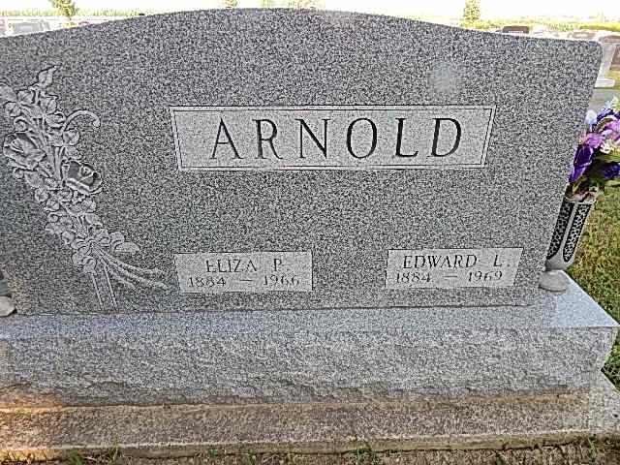

Adams Public Library System (Decatur, IN) online obit abstracts
Publication: Decatur Daily Democrat; Date: 21 NOV 1966
Title: Arnold, Mrs. Edward (Eliza P.)
Subject: Obituaries -- A -- 1960-1969
Abstract: Age 82
Died: Monday, November 21, 1966
Notes:

