Glen D. Adler
October 20, 1912 – March 28, 2003

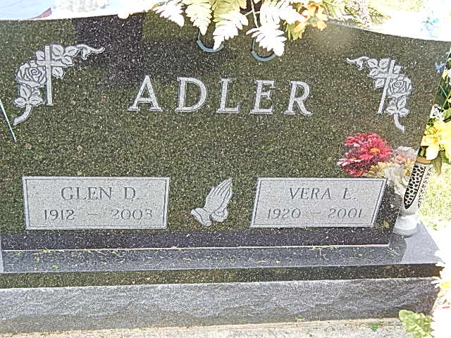

Glen D. Adler, 90, of rural Decatur, died at 10:30 a.m. Friday at home. He was born in Monroe Township on October 20, 1912, to Fred J. and Iva M. Olwin Adler and married Vera L. Wulliman on December 10, 1948; she died on June 20, 2001.
He owned and operated Adler Brothers Garage for more than 50 years in the rural Decatur area and was also a retired farmer. He was a member of Pleasant Dale Church of the Brethren in rural Decatur and during World War II, served in the U.S. Army in France and Germany as a member of the 638th Tank Destroyer Brigade.
Surviving are two sons, Bradford "Brad" Adler of Willshire, Ohio, and Neal O. Adler of Loveland, Colorado; a daughter, Lora J. Penn of Bluffton; five grandchildren; and four great-grandchildren.
Two brothers are deceased.
Funeral services will be held at 1 p.m. Monday in Pleasant Dale Church of the Brethren, with burial in the church cemetery, including military graveside rites by the color guard from American Legion Post 43 in Decatur.
Visiting hours are 11 a.m.-3 p.m. and 5-8 p.m. Sunday in Zwick and Jahn Funeral Home, Decatur, and noon-1 p.m. Monday at the church.
Preferred memorials are to the church and to Family Hospice of Northeast Indiana, at Berne.
Decatur Daily Democrat, Adams County, IN; March 29, 2003

