Lorena Marcella (Braun) Wendel
April 16, 1918 – October 13, 2000
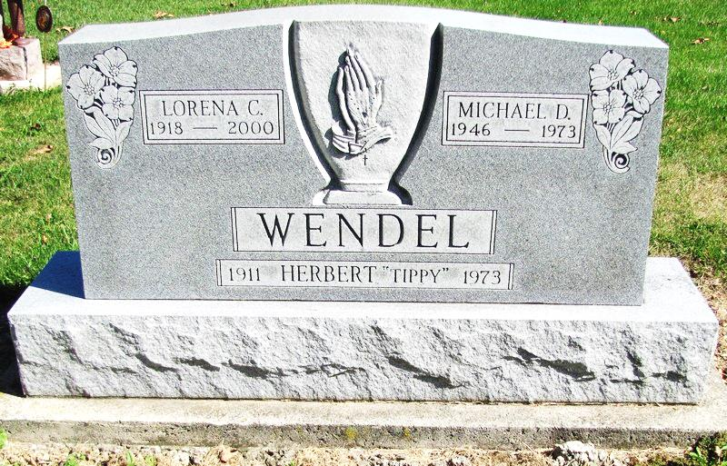
Photo by Jenna Langston

Lorena C. Wendel, 82, a member of St. Mary of the Presentation, died Friday, Oct. 13, 2000, at Lutheran Hospital in Fort Wayne.
The Sharpsburg, Ohio, native was a homemaker and was retired from Jay Garment Co. in Portland. She was a member of the Moose Lodge in Decatur and the Ladies Auxiliary of the VFW in Geneva.
Surviving are her daughters, Mary L. Rausch of Decatur, and Ruth A. Wendel and Jane C. Wendel, both of Bryant; sons Robert R. of New Corydon and Donald L. of Portland; sisters Winnie Ostheimer of New Haven, Rose Mary Roberts of Utah, and Virginia Kelly and Marie Braun, both of Portland; six grandchildren and five great-grandchildren.
She was preceded in death by her husband, Herbert R.; a son, Michael D.; and three brothers.
Services are 10:30 a.m. Monday at St. Mary of the Presentation, with calling from 2 to 9 p.m. Sunday at Downing Funeral Home. Burial will be at St. Mary Church Cemetery. Memorials are to the heart or diabetic foundations.

News-Sentinel, Fort Wayne, IN; October 14, 2000

Contributed by Tracy Clark

