Henry H. “Carson” Welsch

February 17, 1891 – July 21, 1970

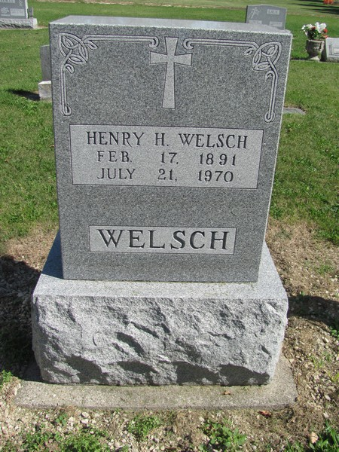

Photo by Jenna Langston

Henry “Carson” Welsch, 79, died at 11 am yesterday at the home of a daughter with whom he was residing, Mrs. Marjorie Doswell, 2626 Shady Oak Drive. He had been ill a short time.

Born in Chattanooga, Ohio, Mr. Welsch came to Fort Wayne 35 years ago. He was an Army veteran of World War I and was a member of St. Henry’s Catholic Church, its Holy Name Society and American Legion Post 82.

Also surviving are two other daughters, Mrs. Imelda Arata, Fort Wayne and Mrs. Rita Turner, Oak Forest, Ill.; two brothers, Joseph of Bryant and Peter, Muncie; and 12 grandchildren.

Services will be at 10 am Friday in Tom Mungovan Funeral Home and at 10:30 am in St. Henry’s Catholic Church, the Rev. James J. O’Connor officiating. Burial will be in St. Mary’s Cemetery, Geneva.

The Holy Name Society will hold services at 7:30 pm Thursday in the funeral home where friends may call after 7 pm today.

**Journal-Gazette, Fort Wayne, IN; July 22, 1970, Page 6A**