Cletus S. Wellman
September 28, 1926 – May 21, 2004
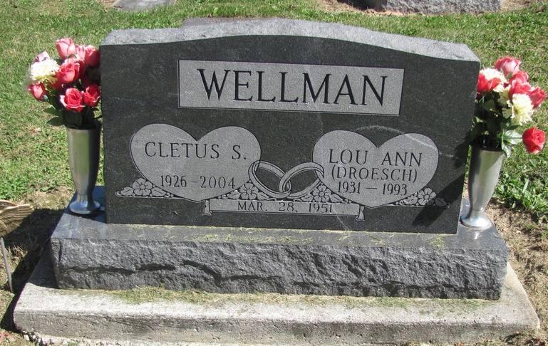
Photos by Jenna Langston

Cletus S. Wellman, 77, 8621 Ohio 49, died at 11:40 p.m., at his residence.
He was born to Phillip and Doretta (Schroer) Wellman. On March 28, 1951, he married Lou Ann Droesch, who preceded him in death June 10, 1993.
Surviving are a son, Daniel (Lois), Celina; two daughters, Norma Jean Pax, Bluffton, IN, and Linda (Ron) Post, Celina; a brother, Lavern, Berne, IN; five sisters, Mildred Brunswick, Fort Recovery, Sally (Wilbert) Reier, St. Henry, Wilma (Jim) Pfeffenberger and Doris Grieshop, all Celina, and Jenny (Dick) Alig, Coldwater; a sister-in-law, Julianna Wellman, St. Henry; eight grandchildren and a step-grandchild. Deceased are a son-in-law, Daniel Pax, and a brother, Norbert.
He formerly owned and operated Wellman Electric in Fort Recovery. He was a member of St. Mary of the Presentation Catholic Church, Geneva, Ind., and served in the U.S. Navy during World War II.
Funeral Mass at the church, the Rev. Raymond Seifert officiating.

Contributed by Mike Dearbaugh – no source listed

