Aveline M. (Robinson) Tschannen
August 23, 1922 – February 4, 1995
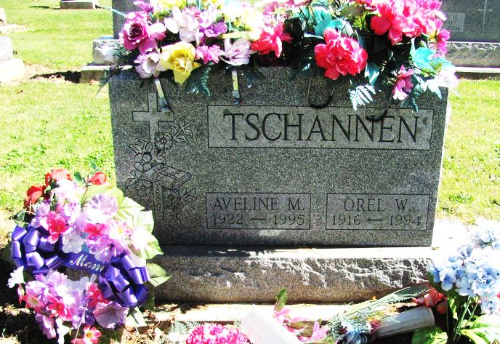
Photo by Jenna Langston

Aveline M. Tschannen, 72, of rural Geneva died Saturday at home.
The Fort Wayne native formerly worked at Adams County Memorial Hospital and General Electric Co., and was the widow of Orel W., who died last year.
Surviving are daughters, Catherine Teeter and Rosemary Tschannen, both of Berne, and Jacqueline Jolliff of Ossian; a son, Ron of Portland; sisters, Dorothy Murphey of Decatur and Barbara Cleveland of Geneva; brothers, Tom Robinson, David Robinson and Eugene Robinson, all of Geneva; nine grandchildren; and three great-grandchildren.
Services are 10 a.m. Wednesday in St. Mary's Catholic Church, Geneva, with burial in the church cemetery. Calling is 2 to 5 and 7 to 9 p.m. tomorrow in Downing Funeral Home, Geneva; with a vigil at 8 p.m. Preferred memorials are gifts to charity.

News-Sentinel, Fort Wayne, IN; February 6, 1995

Contributed by Jane Edson

