Nanna L. (Aurand) Sutton
October 18, 1935 – February 27, 2009
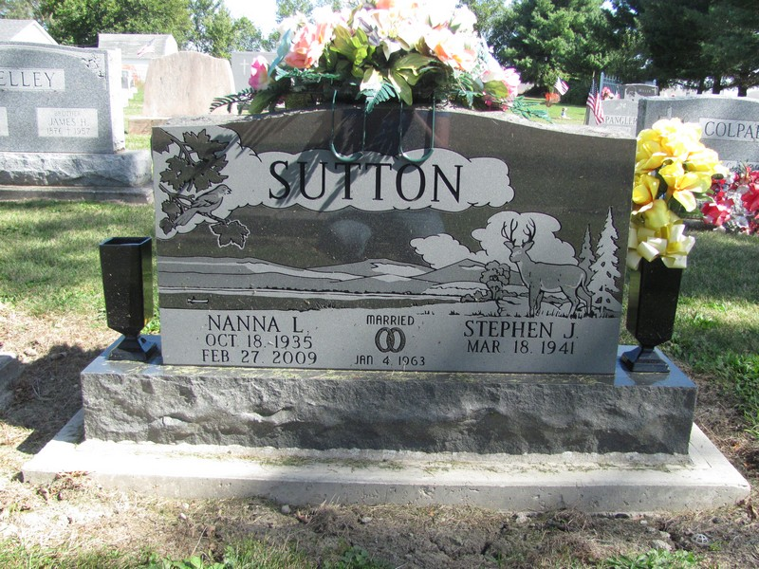
Photo by Jenna Langston

Nanna Lee Sutton, 73, of Berne, died at 7:12 p.m. Friday in Adams Memorial Hospital at Decatur. She was born on October 18, 1935, in Adams County to Elbert L. and Elizabeth J. Peterson Aurand. She had been a homemaker, was a 1954 graduate of Decatur High School, and enjoyed doing jigsaw puzzles and word searches. She also was a member of St. Mary of the Presentation Catholic Church in rural Geneva. She married Steve J. Sutton on January 4, 1963, in Indianapolis and he survives.
Other survivors are five sons, Kevin Fuhrman (and wife Judy) of Monroe, Gary Fuhrman of Fort Wayne, and Stephen Sutton (and wife Sandra), Samuel Sutton (and wife Tamara), and Luke Sutton (and wife Verena), all of Geneva; two daughters, Jodi Callow of Liberty Center and Mrs. Richard (Sheri) Hermann of Decatur; two brothers, Jack Aurand of Monroeville and Thomas Aurand of Avon, Indiana; and 11 grandchildren. One daughter and one grandchild are deceased.
Funeral services will be held at 10:30 a.m. Wednesday in St. Mary of the Presentation Catholic Church, with Father J. Bosco Perera officiating. Interment will be in the church cemetery. Visiting hours are 2-8 p.m. Tuesday and 9-10 a.m. Wednesday in Downing and Glancy Funeral Home, Geneva. Memorials are to St. Mary of the Presentation Catholic Church or to Family Hospice of Northeast Indiana, 265 W. Water St., Berne, 46711.

Decatur Daily Democrat, Adams County, IN; Monday, March 2, 2009

Contributed by Jane Edson

