Jesse C. Sutton
October 6, 1913 – December 27, 1983
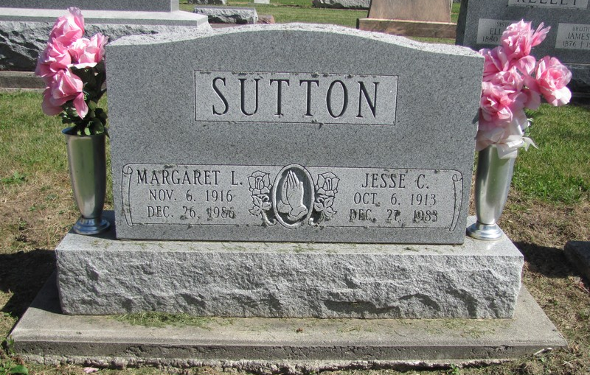
Photo by Jenna Langston

Adams Public Library System (Decatur, IN) online obit abstracts
Publication: Decatur Daily Democrat; Date: 29 DEC 1983
Title: Sutton, Jesse C.
Subject: Obituaries -- S -- 1980-1989
Abstract: Age: 70
Died: December 27, 1983

