David L. Robinson
December 18, 1936 – April 19, 2003
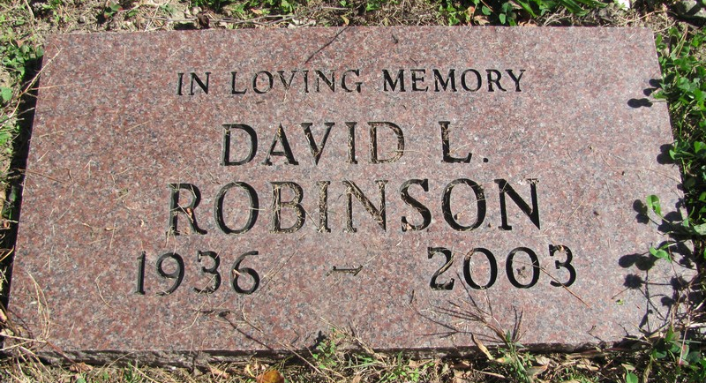
Photo by Jenna Langston
GENEVA –
David L. Robinson, 66, died at 8:30 am Saturday in Parkview Hospital, Fort Wayne. The Adams County native retired as a manager of Marathon Oil Co. in Wabash.
Survivors include daughter Diana Lynn Jacob, Marion; son Dennis Leon, Decatur; brother, Tom, Geneva; sister, Dorothy Murphy, Decatur.
Services: 10:30 a.m. Wednesday in Downing and Glancy Funeral Home, 100 N. Washington St., with the Rev. J. Bosco Perera officiating. Burial: St. Mary's Catholic Cemetery. Visitation: 2-4 and 6-8 p.m. Tuesday at the funeral home.
Memorials may be made to Geneva Proud, P.O. Box 2, Geneva, 46740.
Chronicle-Tribune (Marion, IN); April 21, 2003

Contributed by Jane Edson

