Margaret Jane Robin
1869 - 1935
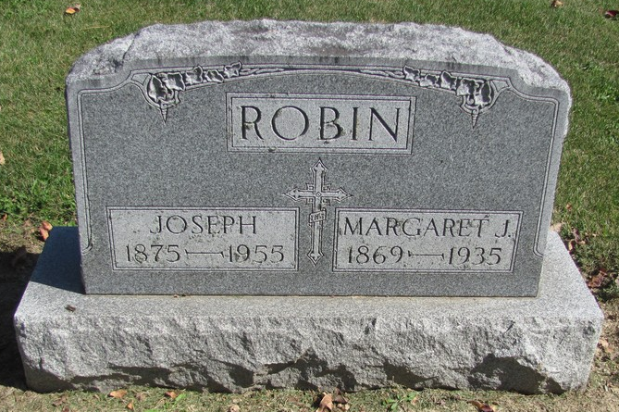
Photo by Jenna Langston

Adams Public Library System (Decatur, IN) online obit abstracts
Publication: Decatur Daily Democrat; Date: 05 JUL 1935
Title: Robin, Margaret Jane
Subject: Obituaries -- R -- 1930-1939
Abstract:

