Karen Sue Rauch
December 18, 1962 – August 3, 1963

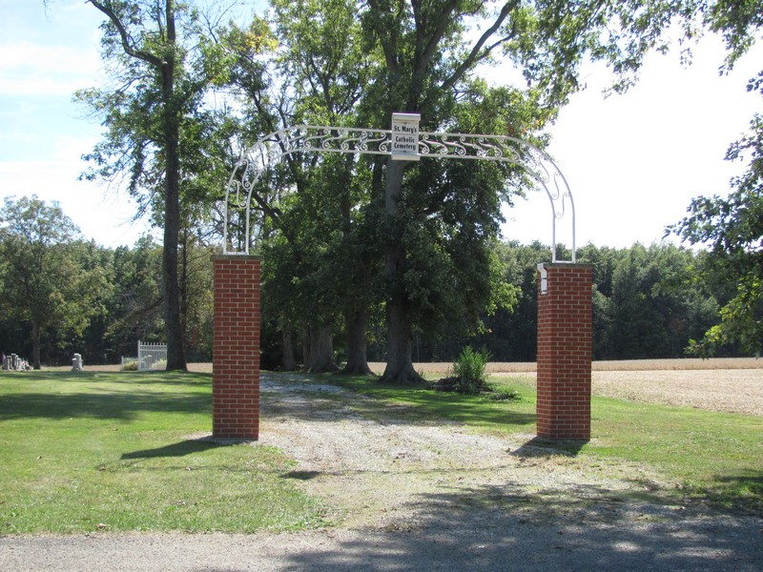
Photo by Jenna Langdon

YOUNG RAUCH CHILD DIES ON SATURDAY
RITES TODAY FOR KAREN SUE RAUCH, SEVEN MONTHS OLD

An acute virus is blamed for the death at 2:30 p.m. Saturday of Karen Sue Rauch, seven-month-old daughter of Mr. and Mrs. Max Rauch of Monroe R.R.1. The child had been ill a week and when her condition became critical Saturday she was rushed to the hospital but died en route.
The child was born December 18, 1962, a daughter of Max and Mary Lou Wendell Rauch. Surviving are the parents; a brother, Rex Allen Rauch, 7, and the grandparents, Mr. and Mrs. Ervin Rauch of Berne R.R. 1, and Mr. and Mrs. Herbert R. Wendell of Bryant R.R. 1.
Services were held at 10 a.m. today at the Yager Funeral home, with burial in St. Mary’s Catholic cemetery in Decatur. The Rt. Rev. Msgr. M. Schmitt, pastor of the St. Mary’s church, officiated at the service. (Mon. Aug. 5, 1963)

Heritage Room, Berne (IN) Library
Adams County Obits 1962-1964, image 32
Transcribed by Janice Vasilovski

