Daniel L. Pax
November 30, 1952 – February 2, 2003
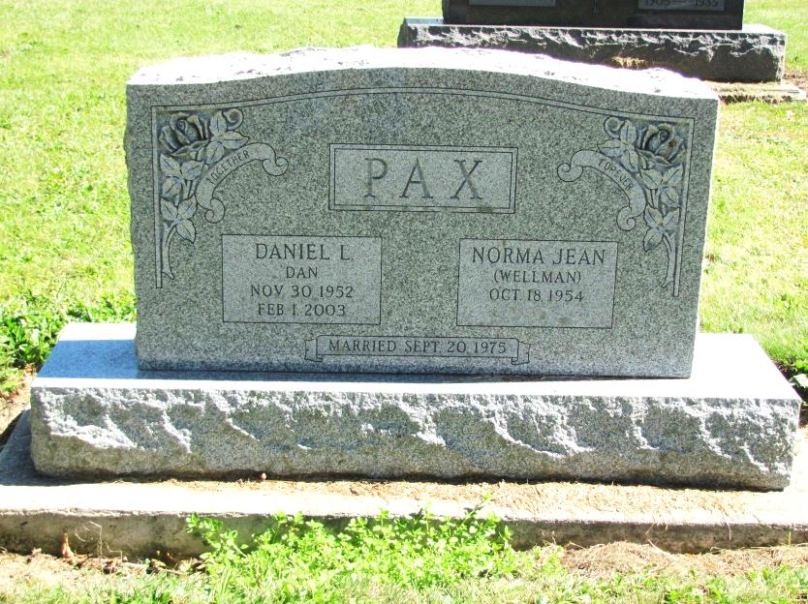
Photo by Jenna Langston

Coldwater native Daniel Pax, 50, of Bluffton, died at 9:25 p.m., at Chalet Village. Death was due to complications from muscular dystrophy. He was born to Robert and Dorothy Timmerman Pax who survive in St. Henry. On Sept. 20, 1975, he married Norma Jean Wellman who also survives.
Other survivors are two sons, Gerald of Bluffton, and Kevin of Kokomo, Ind.; a daughter, Melissa of Bluffton; three brothers, Fred of Denver, Colo., and Richard and Andrew of Fort Recovery; and a sister, Nancy (David) Brown, Redkey, Ind. Deceased is a brother, Timothy.
He was formerly a farmer and later employed in the millroom department at Dunbar Furniture. He graduated from Northwestern Technical College, Archbold.
Funeral Mass was at St. Joseph Catholic Church, Bluffton, the Revs. Larry Kramer and Joseph Pax officiating.
Contributed by Mike Dearbaugh – no source listed

