Cinthia Marie Otto
June 8, 1994 – November 7, 1994
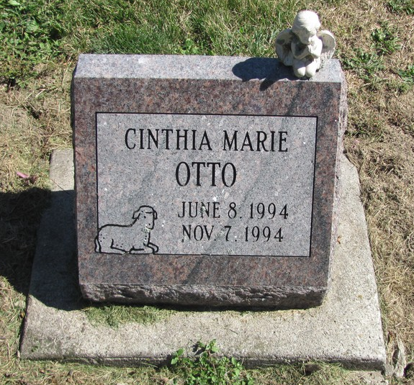
Photo by Jenna Langston

Cinthia Marie Otto, 5 months, of Baumholder, Germany, died Monday.
Surviving are her parents, Gina and Robert Otto III of Baumholder; grandparents, Bernadette and Michael Kelly of Berne, Jo and Kent Christy of Bryan, Texas, Robert J. Otto Jr. of Eau Claire, Wis., and Susan Graves of Brownsville; and great-grandparents, Rose and Robert Otto Sr. of Crystal Falls, Mich., Deloris and Bryce Christy of Berne, and Betty and Jack Stahley, and Margaret and Cedric McAbee, all of Portland.
Services are 11 a.m. Monday in St. Mary's Catholic Church, Geneva, with burial in the church cemetery. Calling is 4 to 8 p.m. tomorrow in Haggard & Armes Funeral Home, Decatur.

News-Sentinel, Fort Wayne, IN; November 12, 1994

Contributed by Jane Edson

