Cora C. Moran
1886 – January, 1968
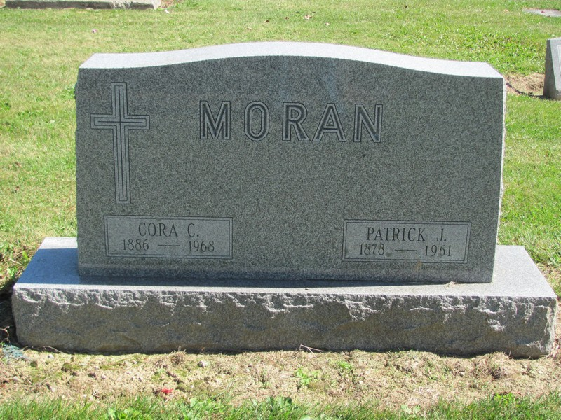
Photo by Jenna Langston

Adams Public Library System (Decatur, IN) online obit abstracts
Publication: Decatur Daily Democrat; Date: 19 JAN 1968
Title: Moran, Cora
Subject: Obituaries -- M -- 1960-1969
Abstract: Age 81
Died in Portland, IN
Married: Patrick Moran

