James Kenney
1858 – March 27, 1936
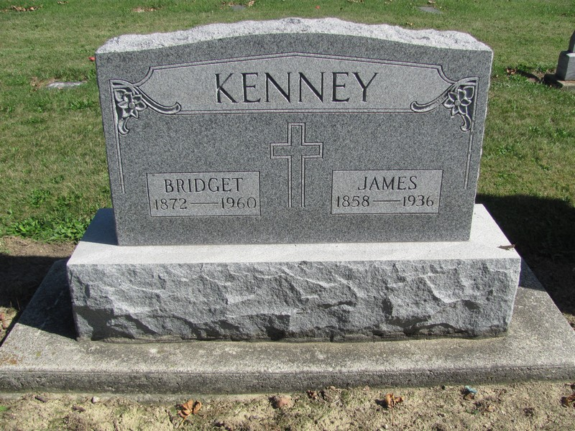
Photo by Jenna Langston

KENNEY
Decatur, Ind., March 28 –
James Kenney, aged 78, former trustee of Jefferson Township, Adams County and for several years a member of the Adams County Council, died Friday night at his home, north of New Corydon.
He is survived by the widow, five daughters and two brothers.

News-Sentinel, Fort Wayne, IN; March 28, 1936, Page 13

Contributed by Jim Cox

