Rita M. (Robinson) Herman
November 15, 1933 – December 27, 1993
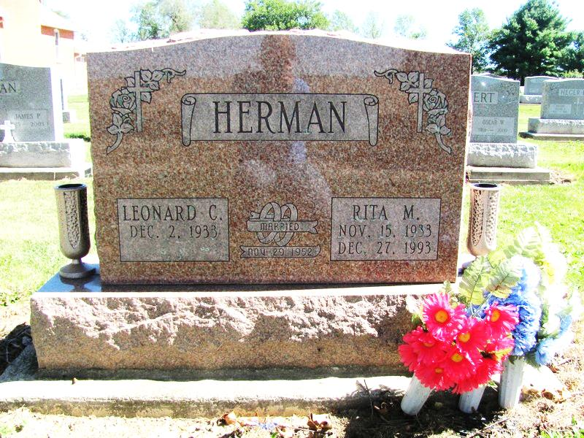
Photo by Jenna Langston

Rita Herman, 60, of rural Geneva died yesterday in Adams County Memorial Hospital.
The Adams County native is survived by her husband, Leonard; a daughter, Teresa at home; sons, Michael of Craigville and Randy at home; a sister, Dorothy Murphey of Decatur, and Barbara Cleveland and Evaeline Tschannen, both of Geneva; brothers, Tom Robinson, David Robinson and Eugene Robinson, all of Geneva; and two grandchildren.
Services are 10 a.m. Friday in Downing Funeral Home, Geneva, where calling is 2 to 9 p.m. Thursday and 9 to 10 a.m. Friday. A vigil is at 8:30 p.m. Thursday in the funeral home. Burial will be in St. Mary Catholic Church Cemetery, Geneva. Preferred memorials are gifts to the church or Adams County Cancer Society.

News-Sentinel, Fort Wayne, IN; December 28, 1993

Contributed by Jane Edson

