Ruth C. (Heger-Harpring) Herbert
May 13, 1894 – July 11, 1986
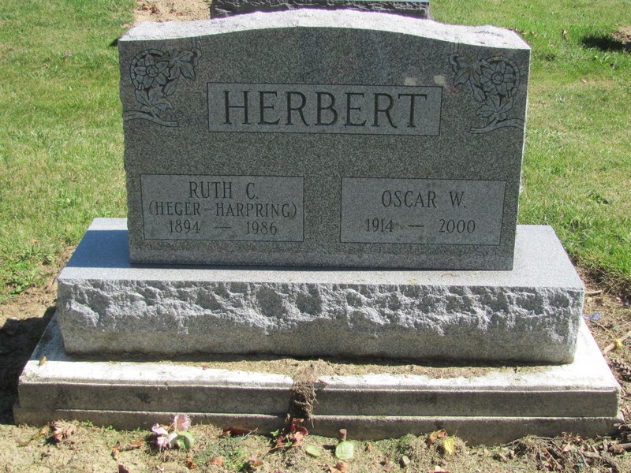
Photo by Jenna Langston
Portland –
Ruth C. Herbert, 92, died at 1:40 am Thursday at Adams County Memorial Hospital, Decatur.
Surviving are her husband, Oscar; three sons, Dennis and Leo Harpring of Geneva, and Ira Harpring of Delta, Ohio; two daughters, Mary Harpring and Rose Grimm, both of Portland; one brother and nine grandchildren.
Services at 10:30 am Saturday at Immaculate Conception Catholic Church; calling after 2 pm today at Baird-Freeman Funeral Home, with a rosary at 8 pm.

Journal-Gazette, Fort Wayne, IN; July 11, 1986, Page 3C

Contributed by Jim Cox

