Mary Helen (Moran) Harpring
October 3, 1919 – December 22, 2006
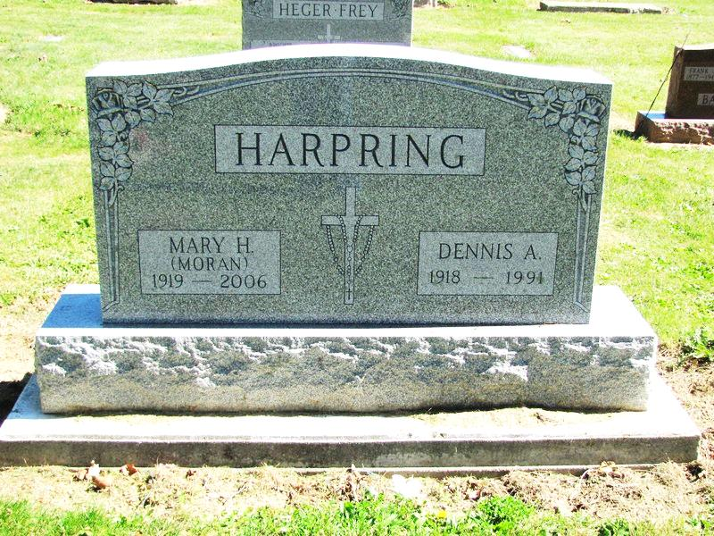
Photo by Jenna Langston

Mary Harpering , 87, died at Woodcrest Nursing Center, where she was a resident.
She was born in Jefferson Township, Ind., to Patrick and Cora (Dickerhoof) Moran. On Aug. 24, 1967, she married Dennis Harpring, who preceded her in death.
Surviving is a niece Mary (Richard) Hertel, Ft. Wayne, Ind.
Deceased are two brothers, James P. and Robert Moran; and a sister, Mildred Brinksneader.
She taught at Sharpsburg, St. Anthony and Northwest Elementary, Decatur, for 46 years. She was 1937 graduate of Jefferson Township High School, Adams County, Ind., Bowling Green State University and Ball State University, Muncie, Ind. She was a member of the Indiana Retired Teachers Association and St. Mary's of the Presentation Altar Sodality.
Services at St. Mary's of the Presentation Church, Geneva, Ind., the Rev. J. Bosco Perera officiating.

Contributed by Mike Dearbaugh – no source listed

