Leo J. Harpring
April 19, 1924 – September 16, 2000
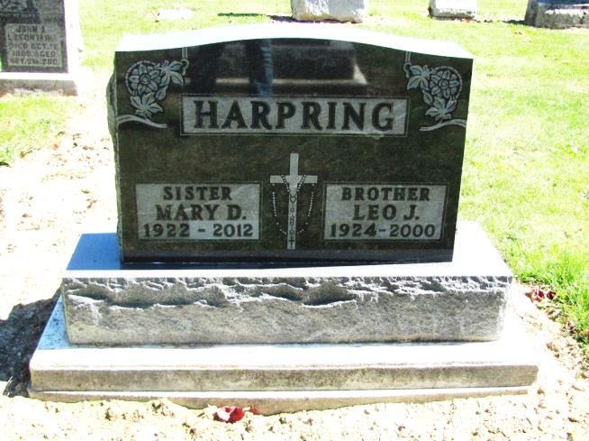
Photo by Jenna Langston

Leo J. Harpring, 76, of Berne and formerly of Geneva, died Tuesday, Sept. 19, 2000, at Chalet Village.
The Decatur native was retired from International Harvester Co. in Fort Wayne and was an area farmer. He was a member of St. John Fisher Traditional Catholic Church in Fort Wayne and the Holy Name Society.
Surviving are his sister, Mary Harpring of Berne; and several nieces and nephews. He was preceded in death by a sister and two brothers.
Services are 9 a.m. Saturday at St. John Fisher Traditional Catholic Church, 3333 E. Tillman Road, Fort Wayne. Calling is from 2 to 5 and 7 to 9 p.m. Friday with an 8 p.m. rosary service at Downing Funeral Home, Geneva. Burial will be at St. Mary's Church of the Presentation Cemetery, Geneva. Memorials are to the donor's choice.

News-Sentinel, Fort Wayne, IN; September 21, 2000

Contributed by Jane Edson

