Dennis A. Harpring
October 6, 1918 – May 14, 1991
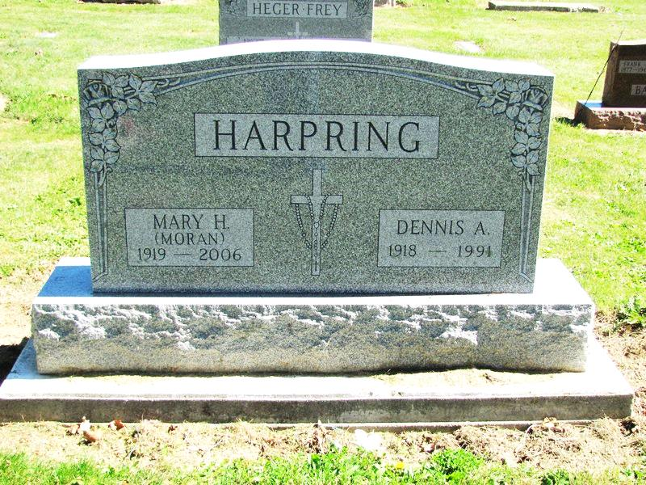
Photo by Jenna Langston

Dennis A. Harpring, 72, of Geneva died yesterday in Adams County Memorial Hospital.
He retired in 1978 from Materials Handling Corp. in Fort Wayne and farming.
Surviving are his wife, Mary Helen; a sister, Mary Harpring of Portland; brothers, Leo of Geneva and Ira of Delta, Ohio; and a stepfather, Oscar Herbert of Portland.
Services are 9:30 am Friday in Downing Funeral Home, Geneva, and 10 am in St. Mary’s Catholic Church with burial in the church cemetery. Calling is 2 to 5 and 7 to 9 pm tomorrow in the funeral home, with a vigil at 8 pm.

News-Sentinel, Fort Wayne, IN; May 15, 1991, Page 3M

Contributed by Jim Cox

