Beulah V. (Donald) Eiting
March 28, 1918 – April 6, 1978
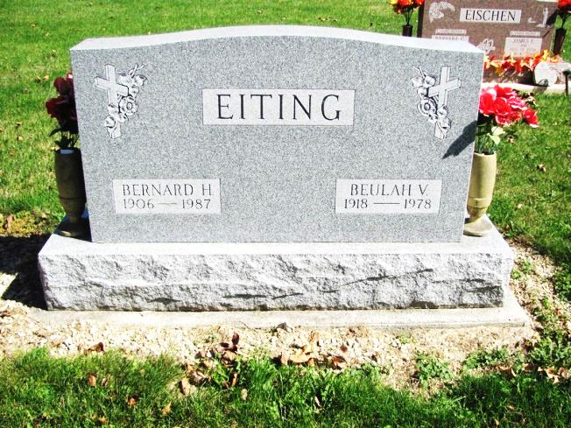
Photo by Jenna Langston

Adams Public Library System (Decatur, IN) online obit abstracts
Publication: Decatur Daily Democrat; Date: 07 APR 1978
Title: Eiting, Beulah V.
Subject: Obituaries -- E -- 1970-1979
Abstract: Age 60
Born: March 28, 1918
Died: Thursday, April 6,1978
Married: Bernard H. "Ben" Eiting in October of 1936
Parents: Theodore G. & Anna Z. Zimmerman Donald
Notes: DPL Scrapbook 5-9-3

