Rosa B. Woodruff
March 17, 1877 – February 12, 1900
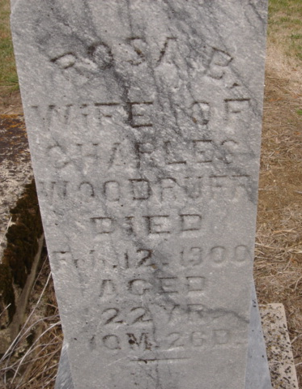
Photo by Cousin Becky
No obit found at this time

