Ray J. Woodruff
September 26, 1898 – November 4, 1899
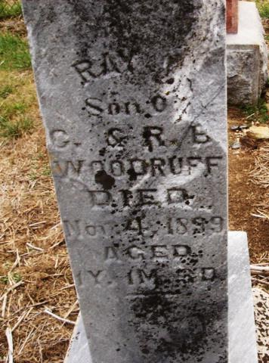
Photo by Cousin Becky
No obit found at this time

