Butler Woodruff
February 24, 1860 – April 20, 1946
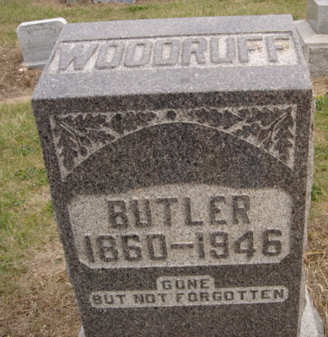
Photo by Dave Buckmaster
No obit found at this time

