David Wintrow
February 23, 1830 – February 16, 1896
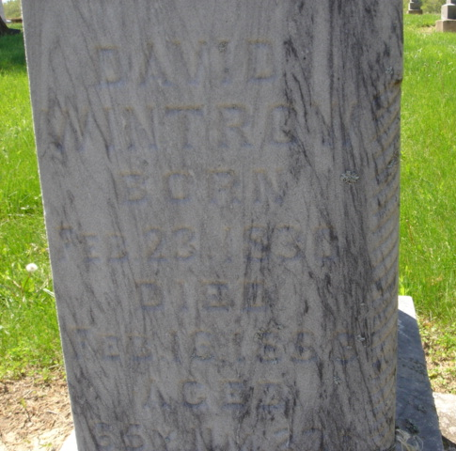
Photo by Cousin Becky
No obit found at this time

