John Thompson
1812 – December 23, 1876
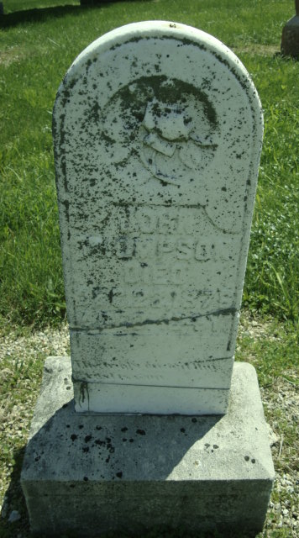
Photo by Cousin Becky
No obit found at this time

