Mary A. (Cromer) Snyder
February 12, 1846 – March 27, 1915
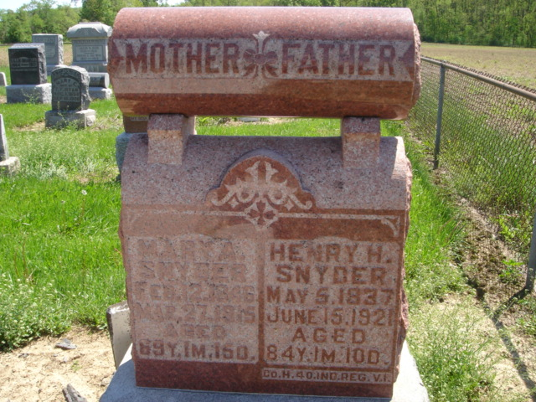
Photo by Cousin Becky
No obit found at this time

