Clarissa C. Skeels
January 20, 1843 – October 2, 1855
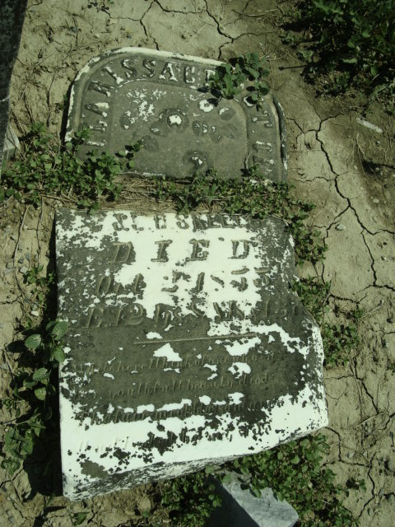
Photo by Cousin Becky
No obit found at this time

