Ora B. Simons
August 19, 1899 – October 4, 1911
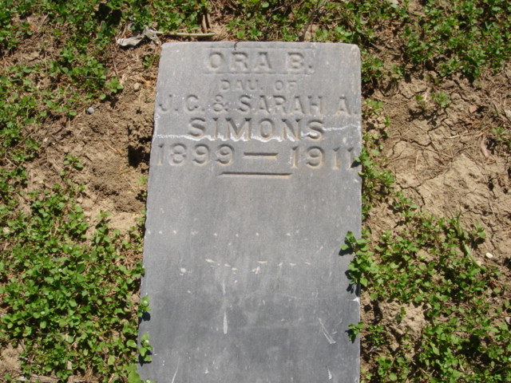
Photo by Cousin Becky
No obit found at this time

