Maggie M. Searight
July 30, 1871 – September 4, 1872
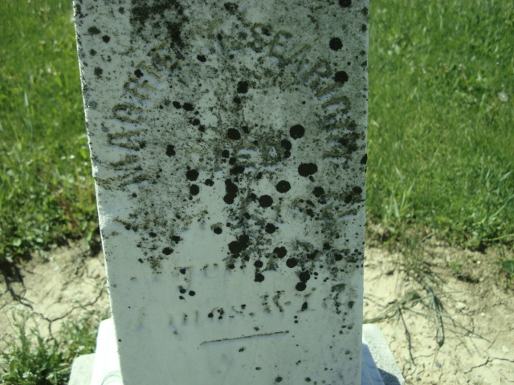
Photo by Cousin Becky
No obit found at this time

