Mary E. (Fetters) Ryan
August 1, 1854 – September 10, 1906
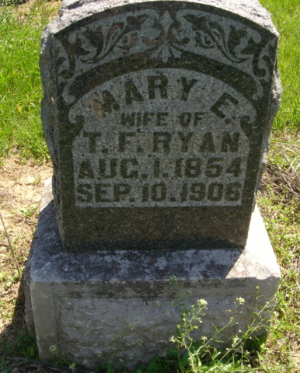
Photo by Cousin Becky
No obit found at this time

