Daniel Rumple
March 7, 1825 – February 5, 1902
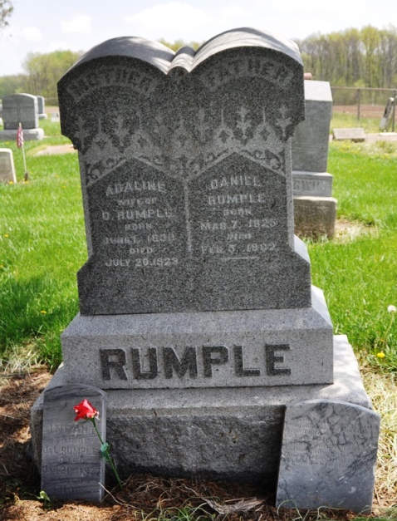
Photo by Deb Curry

Daniel Rumple, a pioneer of Adams County, died recently at the age of 77 years.
Fort Wayne Sentinel (IN); February 14, 1902

Contributed by Karin King

