Jacob N. Rian
February 28, 1823 – June 26, 1916
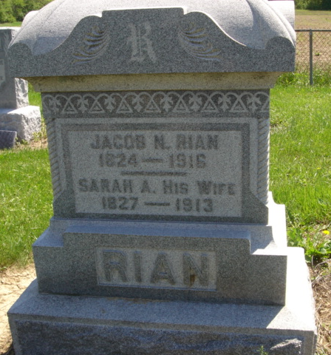
Photo by Cousin Becky

Adams Public Library System (Decatur, IN) online obit abstracts
Publication: Decatur Daily Democrat
Date: 28 JUN 1916
Title: Rian, Jacob M
Subject: Obituaries -- R -- 1910-1919
Abstract: Age: 94

