Hannah Goldy Reid
1894 - 1895
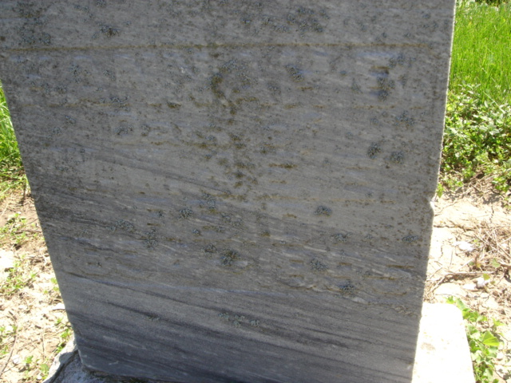
Photo by Cousin Becky
No obit found at this time

