Guy Forest Nash
January 11, 1894 - 1898
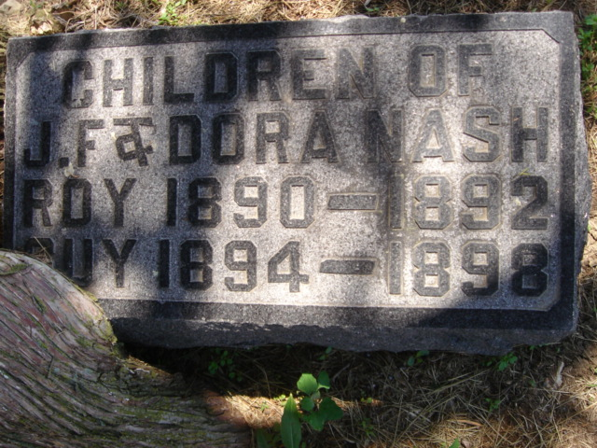
Photo by Cousin Becky
No obit found at this time

