Rachel Olivia Loofbourrow
September 5, 1853 – August 31, 1857
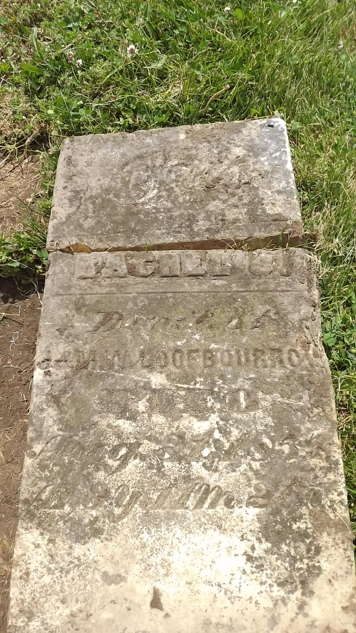
Photo by Cousin Becky
No obit found at this time

