Lemuel S. Loofbourrow
April 5, 1843 – April 8, 1843
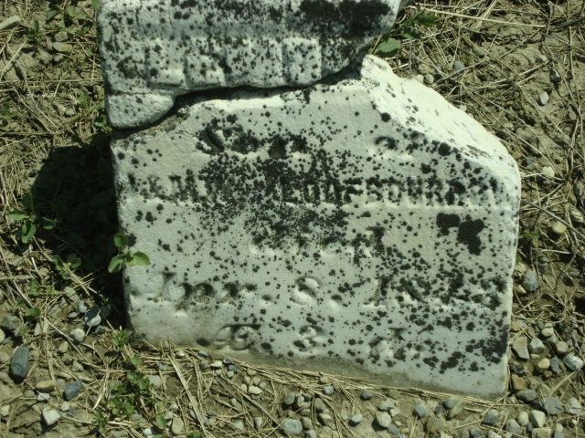
Photo by Cousin Becky
No obit found at this time

