Ebenezer Loofbourrow
September 23, 1790 – October 8, 1850
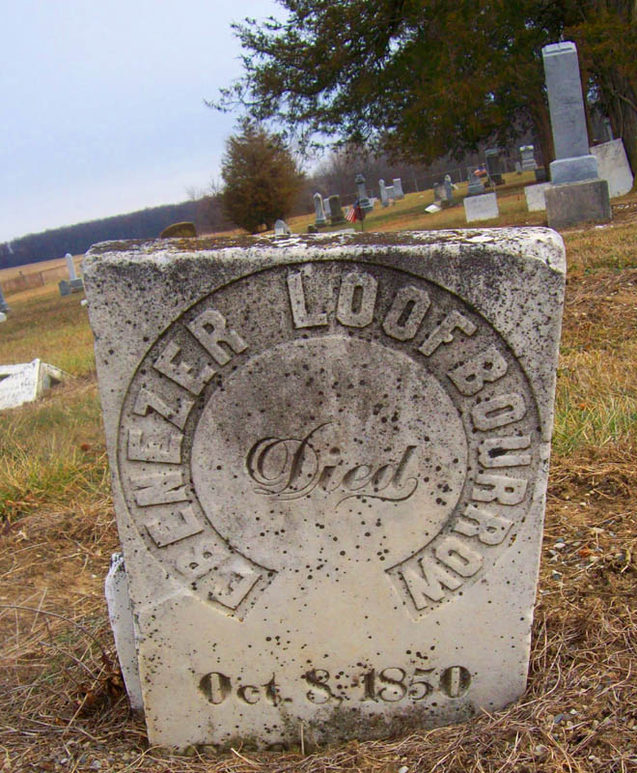
Photo by Dave Buckmaster
No obit found at this time

