Benjamin F. Loofbourrow
June 12, 1823 – July 11, 1849
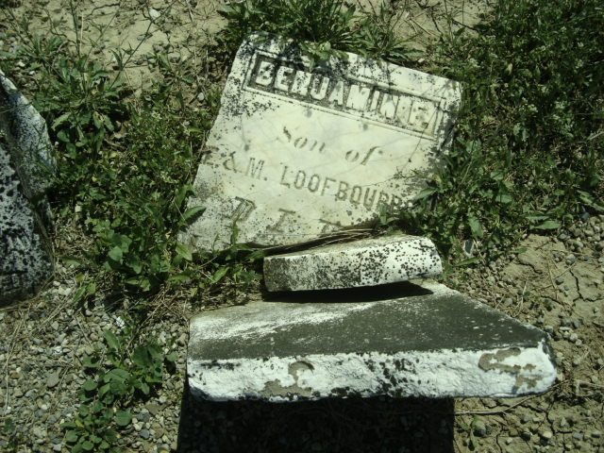
Photo by Cousin Becky
No obit found at this time

