Pearl M. Locker
September 27, 1878 – January 8, 1881
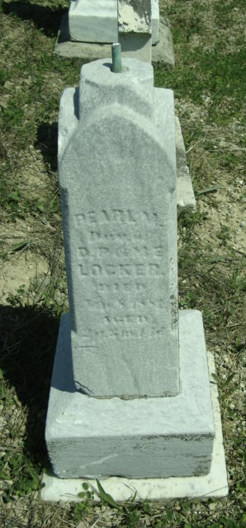
Photo by Cousin Becky
No obit found at this time

