Sherburn Asa Lewis
January 15, 1822 – February 20, 1851
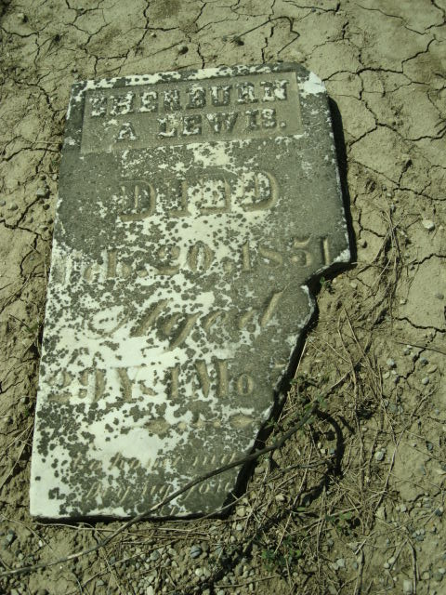
Photo by Cousin Becky
No obit found at this time

