Jonathan Kelly
February 14, 1823 – June 14, 1898
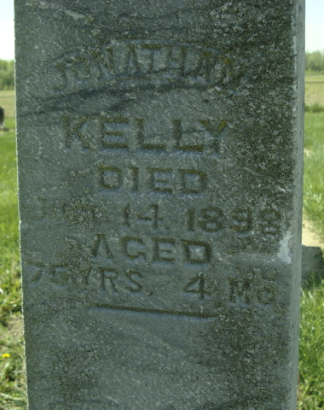
Photo by Deb Curry & Cousin Becky
No obit found at this time

