Jonathan Kelly
January 26, 1797 – September 5, 1855
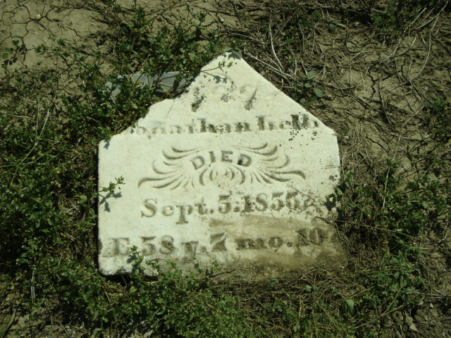
Photo by Cousin Becky
No obit found at this time

