Mary A. Johnson
November 25, 1820 – December 18, 1867
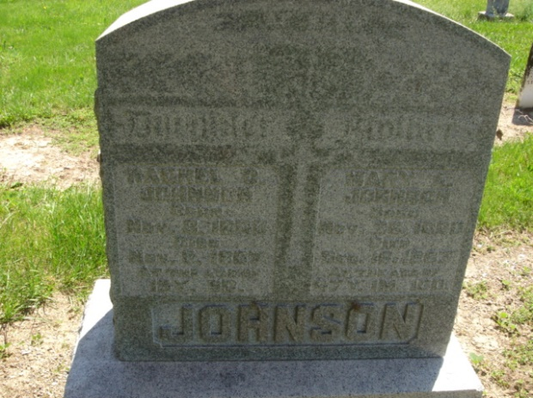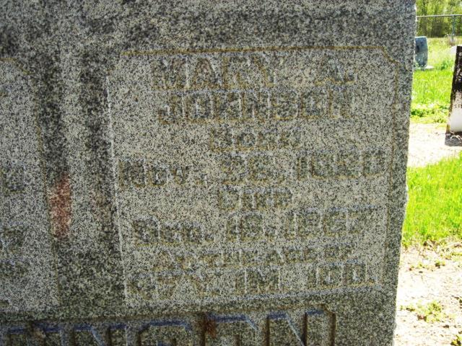
Photo by Cousin Becky
No obit found at this time

