Lurena P. (Dailey) Irwin
February 15, 1875 – July 21, 1925
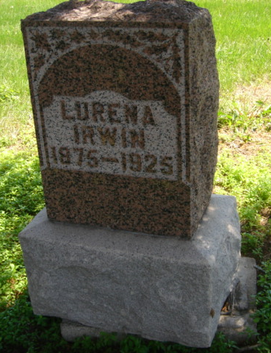
Photo by Cousin Becky
No obit found at this time

